First install VMWare Workstation player<https://www.vmware.com/uk/products/workstation-player/workstation-player-evaluation.html>

Then Install IDE settings image created by Zoe in VM Ware Play:

1. Open VMWare Workstation. Then File-Open- Zoe’s IDE image in github [TBC]
2. Select to import. I got this error, but said OK and it installed correctly:

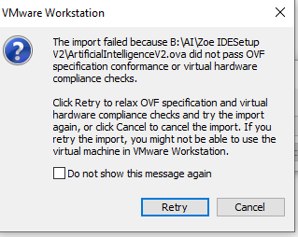

1. During the installation, VMWare complained Intel-VT was not enabled. Enable Intel-VT via Bios-Configuration-Intel Virtual Technology-Enable (other systems may vary). I enabled this after installation and was ok.
2. Open the installed image on VM Ware. VM Ware requests download & install to update software for Ubuntu - Tools for Linux. Accept.
3. The IDE image has username: tensorflow and password: tensorflow
4. Open Android App. The app requests validating the current Android SDK and IDE. Click Next- Standard.
   1. Emulator Settings during validation provides the option to install KVM (if available in your system). Click “Android KVM Linux installation to install” highlighted in blue to test availability and install. N.B. You may first need to update all software and updates (on terminal: sudo apt update).
5. Open Pychar community edition - Help- Update.